**Team Members:**

Roshini Varada- 26

V H N V R S Sai Pavan -27

**Introduction:**

To design a system to signup and login using local storageand to convert the text to speech.

**Objective**

To Convert a keyword from text to speech and to find the calories details of the searched text.

**Softwares Used:**

Visual Studio Code

**Technologies Used:**

Angular 8

**Design/Implementation:**

User can be signed up by putting the details in the local storage in the register page and the user can be authenticated in the login page by getting the same details

 signup(){

      if(this.jsontypedata){

        for(let i=0;i<this.jsontypedata.length;i++){

            if(this.LoginForm.value.UserName==this.jsontypedata[i].UserName){

              this.loop_ended=true;

            }

        }

        if( this.loop_ended!=true){

          this.jsontypedata.push(JSON.parse(this.data));

          localStorage.setItem("dataLogin",JSON.stringify(this.jsontypedata));

          this.router.navigate(['details']);

        }else{

          this.userAlreadyexist=true;

          this.LoginForm.reset();

        }

       }

After the user is authenticated, the user is allowed to search about the food item that he wants to search for.

 <br><h2 class="text-center">Welcome</h2>

                    <br><p class="text-center">Please enter the Name of the food item</p>

                    <div class="text-center">

                    <label for="ItemName">Enter the Item Name</label>

                    <input class="marginadd"  [(ngModel)] ="ItemName" name="ItemName"  id="ItemName" type="text">

                    </div>

                    <div class="row text-center">

                        <div class="col">

                        <button class="btn btn-secondary" type="button" type="submit" (click)="Search()">Search</button>

                        </div>

                    </div>

After entering the key word it is converted to the speech using responsive.org api.Sign up in to the website for creating an API key. After generating the key include the external script in the index.html.

<script src="https://code.responsivevoice.org/responsivevoice.js?key=YOURAPIKEY"></script>

After that display the details from the below API by generating the key after signing up for the below website and displaying the details.

https://api.nutritionix.com/v1_1/search/

.

Bootstrap is used to create the responsive websites.

**Outputs/Results**

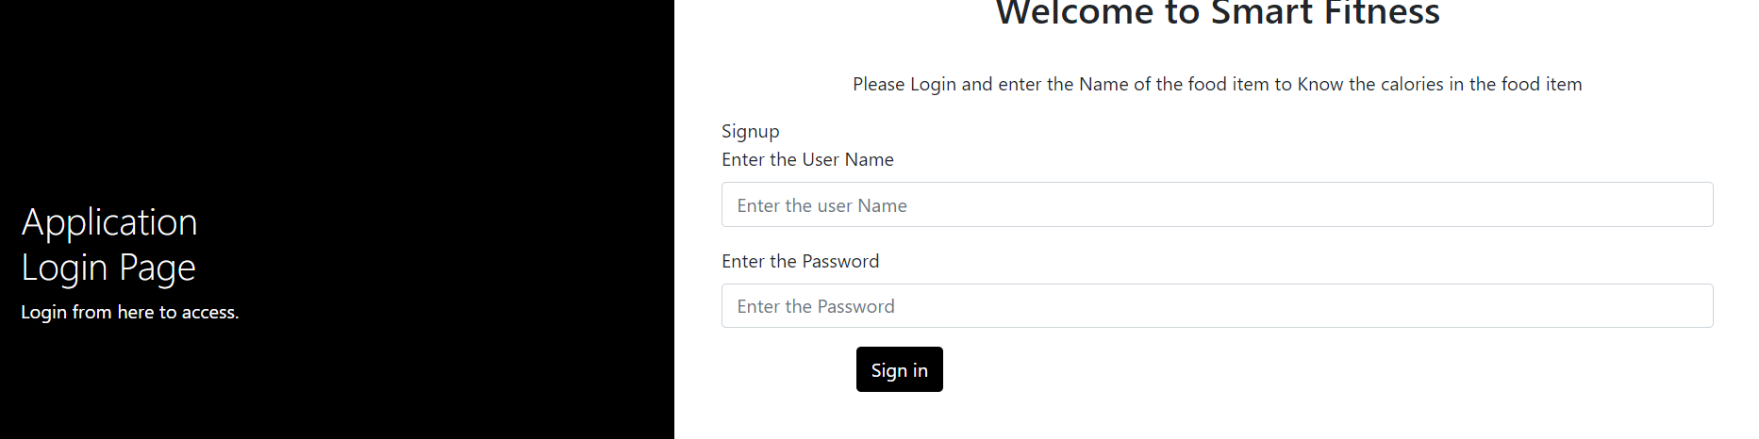

**Login screen**

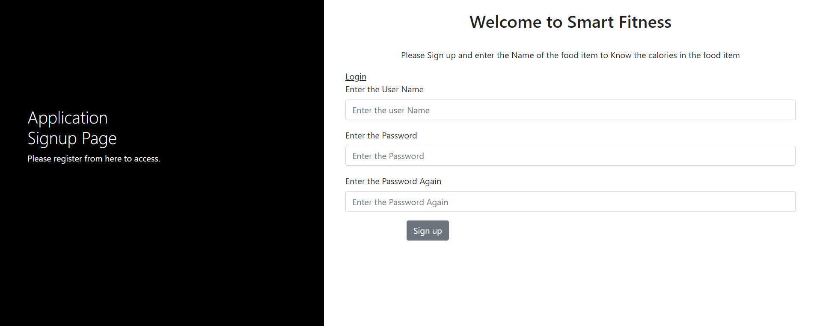

**Signup screen**

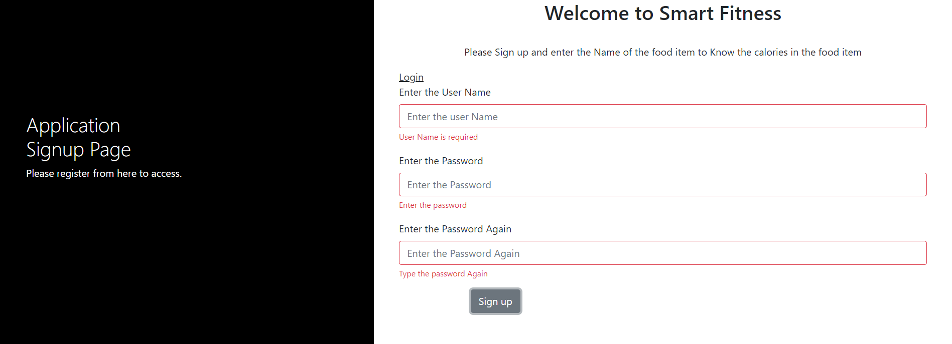

**Validations for signup screen**

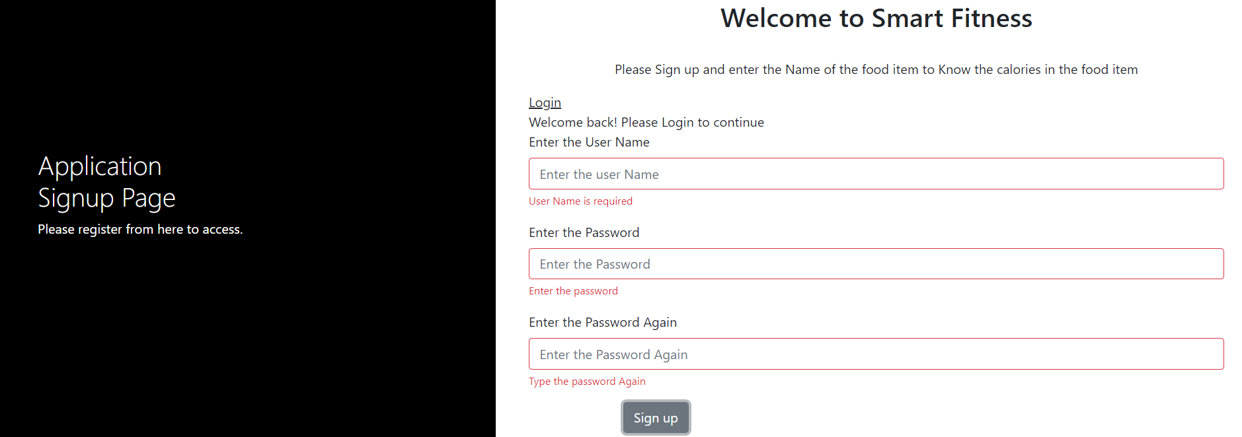

**If the user is already registered but trying to signup again**

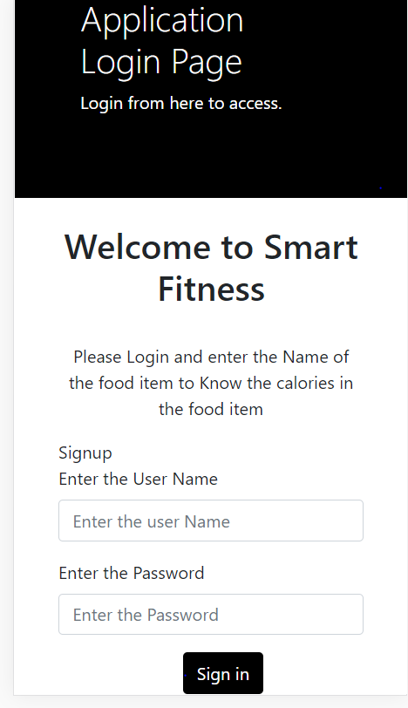

**Responsive design of login in screen**

**Food Calories page responsive design**

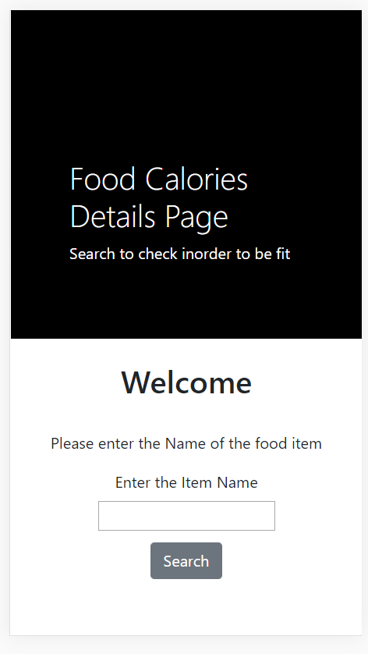

**Details of the food item entered**

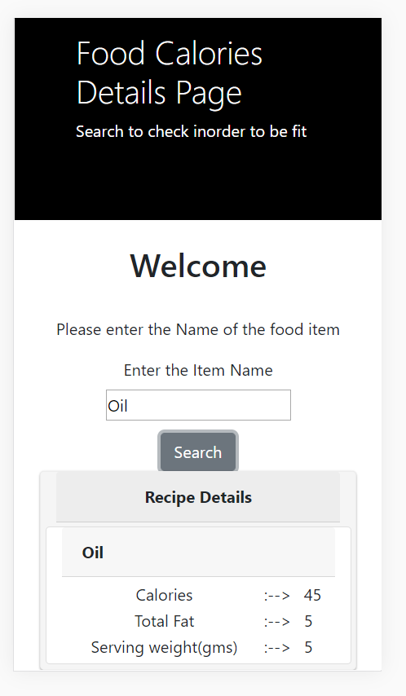

**Conclusion:**

The responsive designs can be created in an easy pattern with the help of bootstrap grid pattern. And the text can be converted to speech using the responsive voice API.The details about the food item can be obtained from nutrition API.